New laminated vitrimer composites developed with unique
restoration properties
Guoqiang Li & John Konlan, Lousiana State University

Award Title: | Louisiana Materials Alliance (LAMDA)
NSF Award Number: | NSF OIA-1946231
Principal Investigator: | Michael Khonsari
Lead Institution Name: | Lousiana State University
Award Start Date: | 07/01/2020
Award End Date: | 06/30/2025
Highlight Submission Date: | 02/28/2023

What is the outcome or accomplishment? (1-2 short sentences describing it and why it is transformative; 50-word maximum suggested)*
Using a self-healing vitrimer-based shape memory polymer, a cohort of LAMDA researchers have developed a multifunctional composite laminate with strain sensing, delamination self- healing, deicing in low temperature cryogenic environments, and room temperature shape restoration. The laminate provides new approach to multifunctional laminate design and manufacturing.

What is the impact? (1-2 simple sentences describing the benefits for science, industry, society, the economy, national security, etc.; suggested 50-word maximum)
The laminated hybrid composites have potential applications in frozen temperate regions. This will help NASA and the U.S. National Laboratories to design and test new satellites for exploring extremely cold environments like Antarctica. It will also facilitate U.S. space exploration agencies to increase the deployment of lightweight smart composite structures to space by reducing cost for space travel.

What explanation/background does the lay reader need to understand the significance of this outcome? (1-2 paragraphs that might include, for example, more on who, when, where; NSF's role; support from multiple directorates/offices; what makes this accomplishment unique; additional intellectual merits; or broader impacts such as education, outreach, or infrastructure improvement that are integral to this outcome; suggested 150-word maximum)
Lightweight composite structures are widely used in aviation, automobiles, ships, medical devices, construction etc. When used in transportation and unmanned aerial vehicles, a huge gain in energy efficiency is realized due to their lightweight architecture. For the majority of research conducted in lightweight structures, very few focus on self-healing and utilization in adverse environments. The drawback is that most of the lightweight composites are non-conducting, limiting their usage in multifunctional applications. Guoqiang Li’s research group has conducted experiments and improved the design and manufacturing procedure for making the hybrid composite structure. They use a novel vitrimer-based shape memory polymer with covalent adaptable network (CAN) as the matrix and reinforced with conducting sinusoidal Shape Memory Alloy (SMA) z-pins. The idea is that the SMA z-pins will facilitate the heating, closing up of delamination and aiding with healing in-situ without human intervention. This smart composite system extends the service life of the laminate in adverse temperature regions, resulting in smart, sustainable lightweight structures for engineering applications.
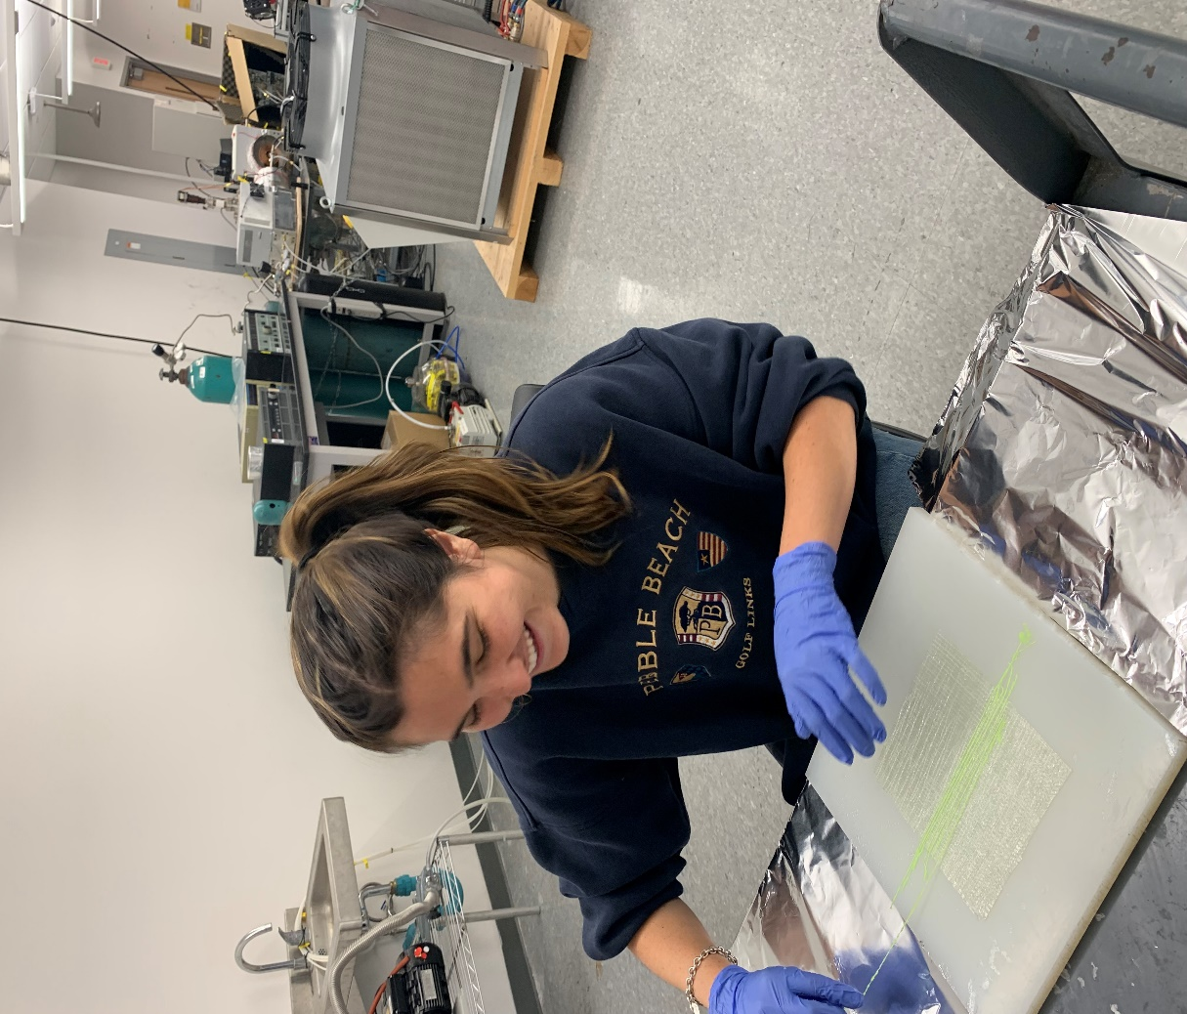
Louisiana State University student Isabella Sabbaghian works on a laminated composite.

