Innovative LAMDA Program Provides Research and Industry Experience for Undergraduates

Award Title: | Louisiana Materials Design Alliance (LAMDA)
NSF Award Number: | NSF OIA-1946231
Principal Investigator: | Michael Khonsari
Lead Institution Name: | Louisiana State University
Award Start Date: | August 2020
Award End Date: | July 2025
Highlight Submission Date: | 03/22/2023

What is the outcome or accomplishment? (1-2 short sentences describing it and why it is transformative; 50-word maximum suggested)*
The Louisiana Materials Design Alliance (LAMDA) developed an innovative program for Louisiana undergraduate students called “Extended/Reverse Research Experiences for Undergraduates (E/RREU).” The program supports the development of a STEM workforce that meets the needs of advanced manufacturing industries and enhances the impact of NSF investments in the jurisdiction.

What is the impact? (1-2 simple sentences describing the benefits for science, industry, society, the economy, national security, etc.; suggested 50-word maximum)

The program provides opportunities for students to gain invaluable analytical and critical thinking research skills through engagement with LAMDA researchers and hands-on experience through industrial partners. The research experiences often earn the students co-authorship on published research papers. These academic-industrial experiences enhance the impact of NSF investments in the jurisdiction and further develop the industrial partnerships.

What explanation/background does the lay reader need to understand the significance of this outcome? (1-2 paragraphs that might include, for example, more on who, when, where; NSF's role; support from multiple directorates/offices; what makes this accomplishment unique; additional intellectual merits; or broader impacts such as education, outreach, or infrastructure improvement that are integral to this outcome; suggested 150-word maximum)

The E/RREU is a year-long research program in which undergraduate students work with LAMDA investigators during the academic year and spend all or part of the summer in an industrial company, national lab, or leading academic research and development group.

So far, the new program has provided E/RREU experiences for 18 undergraduate students who performed research for LAMDA research projects at Louisiana Tech University, Louisiana State University, and Tulane University, and summer internships at industrial companies and laboratories such as the NASA Marshall Space Flight Center, Entergy, Chevron, the Institute for Human and Machine Cognition, and Forte & Tablada, Inc. Students continue to receive mentoring by LAMDA researchers that will help them navigate their journeys to graduate school and/or the workforce.

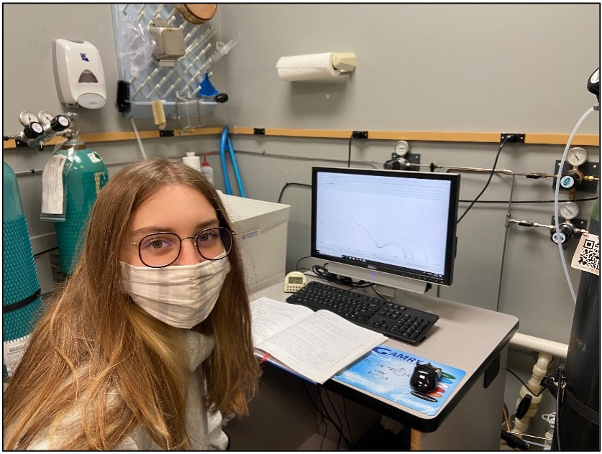 | 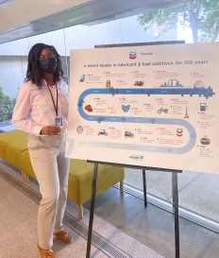

(Left) Louisiana Tech University undergraduate student, Sarah Campbell, was mentored by LAMDA researcher, Dr. Erica Murray, and had a summer internship at Graphics Paper. (Right) Southern University undergraduate student, Raelyn Henderson, was mentored during the school year by LAMDA researcher, Dr. Stephen Akwaboa, and had a summer internship at Chevron.

