New Hybrid Polymeric Syntactic Foams Developed
Siavash Sarrafan, Guoqiang Li, Louisiana State University

Award Title: | Louisiana Materials Alliance (LAMDA)
NSF Award Number: | NSF OIA-1946231
Principal Investigator: | Michael Khonsari
Lead Institution Name: | Louisiana State University
Award Start Date: | 07/01/2020
Award End Date: | 06/30/2025
Highlight Submission Date: | 02/21/2023

What is the outcome or accomplishment?
LAMDA researchers developed the concept of hybrid polymeric foams consisting of both an open-cell structure and syntactic foams. Using this concept, the research team prepared, tested, characterized, and modeled a shape memory polymer (SMP) hybrid foam with two-way actuation properties. The effect of the open-cell porosity on the two-way SMPs was also studied for the first time.

What is the impact?
This study introduced two new classes of materials: hybrid foams consisting of both open-cell and hollow glass microbubbles (HGMs), as well as open-cell SMPs. In particular, the combination of these two creates game-changing options for lightweight controllable filtration, insulation, acoustic, absorption/retention, and actuator devices.

What explanation/background does the lay reader need to understand the significance of this outcome?
Shape memory polymers are a type of polymer that can change their shape via a trigger of heat, light, electric current, or other similar forms of energy. Polymers made of foams have numerous applications that include biomedical devices, insulation, aerospace components, and smart textiles.

The addition of two-way actuation, which means the shape conversion can be reversible, improves the current use of foamed polymers that can be tailored for many new applications.

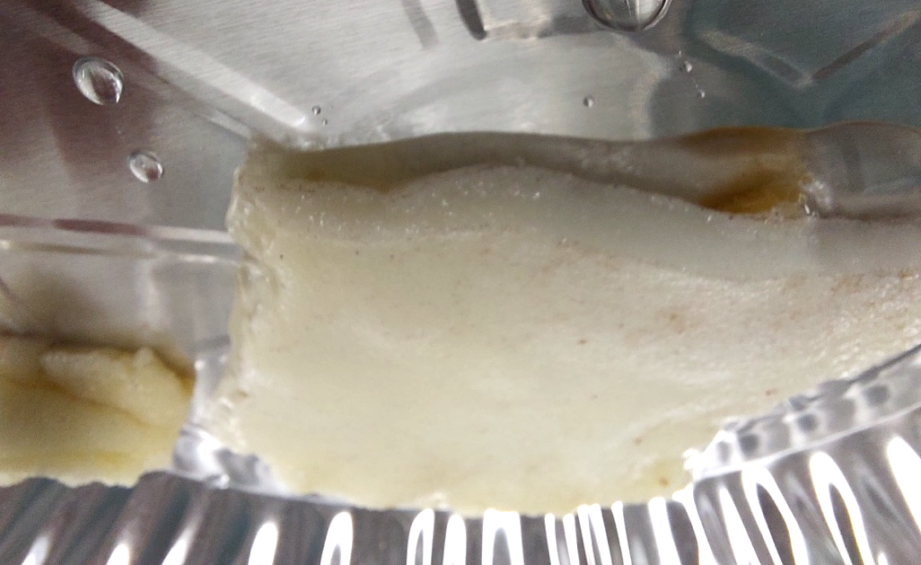

A sample syntactic-hybrid based open-cell shape memory polymer foam retaining a great amount of water, showing one if its great potential applications considering its two-way actuation capabilities.

