Computationally-guided design of new multiphase alloys

Collin Wick, Louisiana Tech University
Jonathan Raush, University of Louisiana at Lafayette
Wen J. Meng and Shengmin Guo, Louisiana State University

Award Title: | Louisiana Materials Design Alliance (LAMDA)
NSF Award Number: | NSF OIA-1946231
Program Director: | Michael Khonsari
Lead Institution Name: | Louisiana State University
Award Start Date: | August 1, 2020
Award End Date: | July 31, 2025
Highlight Submission Date: | 02/20/2023

What is the outcome or accomplishment? (1-2 short sentences describing it and why it is transformative; 50-word maximum suggested)*
LAMDA researchers combined physics-based simulation methods and experimental validation to design new alloys suitable for solid state friction stir-based additive manufacturing. These new alloys have special properties, namely coexisting metal phases with specific compositions.

What is the impact? (1-2 simple sentences describing the benefits for science, industry, society, the economy, national security, etc.; suggested 50-word maximum)
Friction-stir-based 3D metal alloy printing (FSAM) is a new high-throughput additive manufacturing technology with promising applications to aerospace and other industrial sectors. Alloys with balanced mechanical properties, including controlled dependence of strength on temperature, are needed for FSAM, and the researchers demonstrated a computation-forward pathway for designing such materials.

What explanation/background does the lay reader need to understand the significance of this outcome? (1-2 paragraphs that might include, for example, more on who, when, where; NSF's role; support from multiple directorates/offices; what makes this accomplishment unique; additional intellectual merits; or broader impacts such as education, outreach, or infrastructure improvement that are integral to this outcome; suggested 150-word maximum)
FSAM fabricates alloy parts additively through softening and plastic deformation of the feedstock by friction-induced temperature increases without causing melting. Ideal alloys for FSAM exhibit high strength at operating temperatures but lower strength during fabrication to facilitate the AM process. As established alloys may not possess such balanced mechanical properties, identifying suitable new alloys becomes important. The strategy was to identify new alloys exhibiting a transformation from multiple phases to a single phase as temperature increases, with a consequent change in mechanical properties. The vast composition space of complex concentrated alloys offers a test case for this strategy, to address the research challenge of establishing an efficient protocol for searching through the composition space. By combining thermodynamic modeling and atomistic simulations, we demonstrated that new alloy compositions can be identified in a high-throughput manner and validated our predictions with experimental synthesis and characterization.

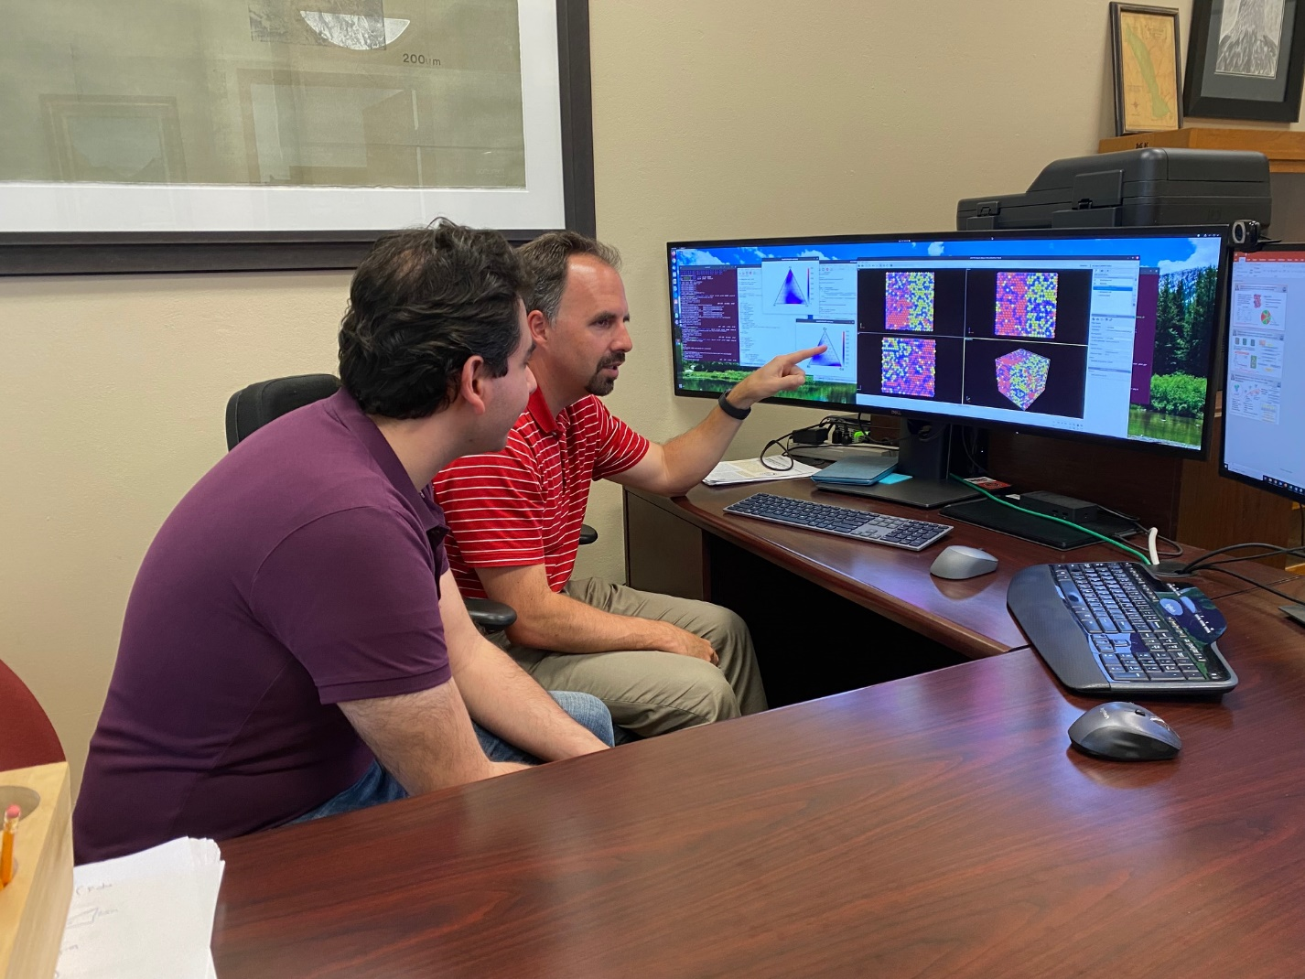
Louisiana Tech University graduate student, Hamid Sharifi Torki (left), and Dr. Collin Wick (right) discuss results from modeling complex conjugated alloys in instances where they demix.

