Neutron Imaging of Al6061 Prepared by Solid-State Friction Stir Additive Manufacturing
Saber Nemati, Leslie G. Butler, and Shengmin Guo, Louisiana State University

Award Title: | Louisiana Materials Alliance (LAMDA)
NSF Award Number: | NSF OIA-1946231
Principal Investigator: | Michael Khonsari
Lead Institution Name: | Louisiana State University
Award Start Date: | July 1, 2020
Award End Date: | June 30, 2025
Highlight Submission Date: | March 11, 2022

What is the outcome or accomplishment? (1-2 short sentences describing it and why it is transformative; 50-word maximum suggested)*
Solid-state Additive Friction Stir Deposition (AFS-D) is a versatile, low temperature metal additive manufacturing process which may be used to build, coat, join or repair three-dimensional, large metal components. AFS-D has recently gained attention for the capacity to fabricate large-scale parts. LAMDA researchers have employed neutron imaging techniques with 90% total transmission per centimeter, to study AFS-D fabricated Al6061 parts for the first time. The results show the fabricated parts with an optimized set of processing parameters are free of voids.

What is the impact? (1-2 simple sentences describing the benefits for science, industry, society, the economy, national security, etc.; suggested 50-word maximum)
Neutron imaging has shown to be effective in nondestructive evaluation of large additive manufactured parts. This research has made it possible to make use of cutting-edge facilities at Oak Ridge National Laboratory and improve the collaboration between LAMDA researchers, the industry sector, and National Lab scientists.

What explanation/background does the lay reader need to understand the significance of this outcome? (1-2 paragraphs that might include, for example, more on who, when, where; NSF's role; support from multiple directorates/offices; what makes this accomplishment unique; additional intellectual merits; or broader impacts such as education, outreach, or infrastructure improvement that are integral to this outcome; suggested 150-word maximum)
Additive Friction Stir Deposition (AFS-D)—commonly known as the MELD® process—is a solid-state additive manufacturing technology inspired by the Friction Stir Welding process and capable of fabricating large parts with relatively simple geometries, making it an ideal fabrication method for the aerospace, defense, and ship building industries. However, finding the optimized set of processing parameters and controlling the uncertainties is a crucial factor for the qualification of the fabricated parts.

For metal additive manufactured items, a neutron beam, as opposed to an X-ray beam, can penetrate deep into most of the materials and is a suitable choice for the non-destructive evaluation of the internal features of large objects. Therefore, neutrons are the perfect choice for investigating the internal features of Al6061 MELD samples. Signs of hydrogen contamination are observed in the fabricated part, which are most likely due to the hydrocarbon-based lubricant used during the deposition process.

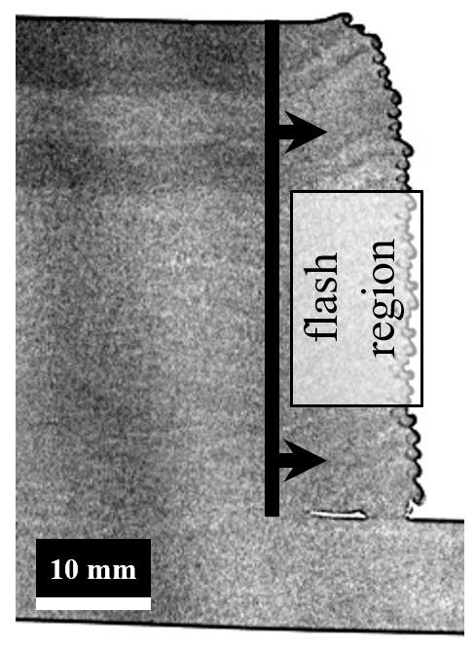 | 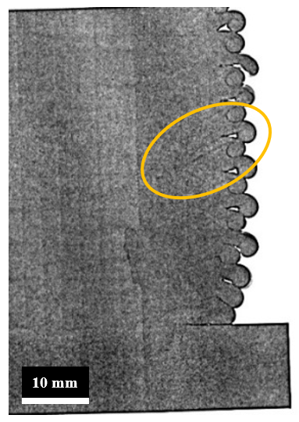
(a) | (b)
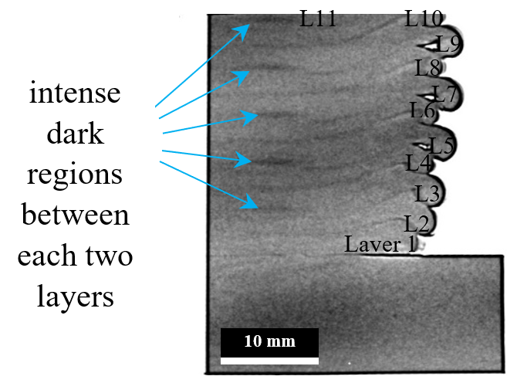
(c)

Illustration of transmission images: (a) a 10-mm-thick slab with 1 mm layer thickness; (b) a 10-mm-thick slab with 2.5 mm layer thickness. The vertical feature is the result of surface roughness, not internal defects. Encircled area shows the layering structure; (c) A 20-mm-thick slab with 2.5 mm layer thickness. The interlayer regions are clearly visible in this image and shown with arrows. This snapshot shows 11 deposited layers, denoted on the image (Layer 1, L2, … L11).

