Automated Defect Analysis of Additively Fabricated Metallic Parts using Deep Convolutional Neural Networks
Saber Nemati, Xin Li, Leslie G. Butler, and Shengmin Guo, Louisiana State University

Award Title: | Louisiana Materials Alliance (LAMDA)
NSF Award Number: | NSF OIA-1946231
Principal Investigator: | Michael Khonsari
Lead Institution Name: | Louisiana State University
Award Start Date: | July 1, 2020
Award End Date: | June 30, 2025
Highlight Submission Date: | March 11, 2022

What is the outcome or accomplishment? (1-2 short sentences describing it and why it is transformative; 50-word maximum suggested)*
LAMDA researchers have developed a trained network capable of segmenting the unbalanced classes of pores and cracks with a mean Intersection over Union (mIoU) value of 82% on the test set, thereby reducing the characterization time from a few weeks to less than a day compared to conventional manual methods.

What is the impact? (1-2 simple sentences describing the benefits for science, industry, society, the economy, national security, etc.; suggested 50-word maximum)
The results show that artificial intelligence (AI) architectures are able to mimic human experts up to 82%. However, full reliance on erroneous human-labeled data prevents leveraging the full discrimination capacity of the AI architectures. This brings up the necessity of uncertainty analysis of manually segmented images and applying zero-shot learning.

What explanation/background does the lay reader need to understand the significance of this outcome? (1-2 paragraphs that might include, for example, more on who, when, where; NSF's role; support from multiple directorates/offices; what makes this accomplishment unique; additional intellectual merits; or broader impacts such as education, outreach, or infrastructure improvement that are integral to this outcome; suggested 150-word maximum)
In the Industry 4.0 era and the emergence of additive manufacturing (AM) and digital twins, data-driven material development and manufacturing process optimization has become possible due to the abundance of data. Finding the correlation between the parameters throughout the process can help researchers simulate and adjust the parameters in a controlled way to get superior material properties. Currently, the most feasible solution to huge amount of available data is AI-assisted data processing.

X-ray Computed Tomography (XCT) is an effective nondestructive evaluation of AM parts. A key factor in interpretation of the experimental X-ray imaging data is segmentation into images with information content close to ground truth. To address this issue, automated evaluation and quantification of a large tomography dataset of a Ni-939 sample fabricated using L-PBF method is studied. The results show that AI architectures can mimic human experts up to 82% for detecting cracks and pores inside AM samples.

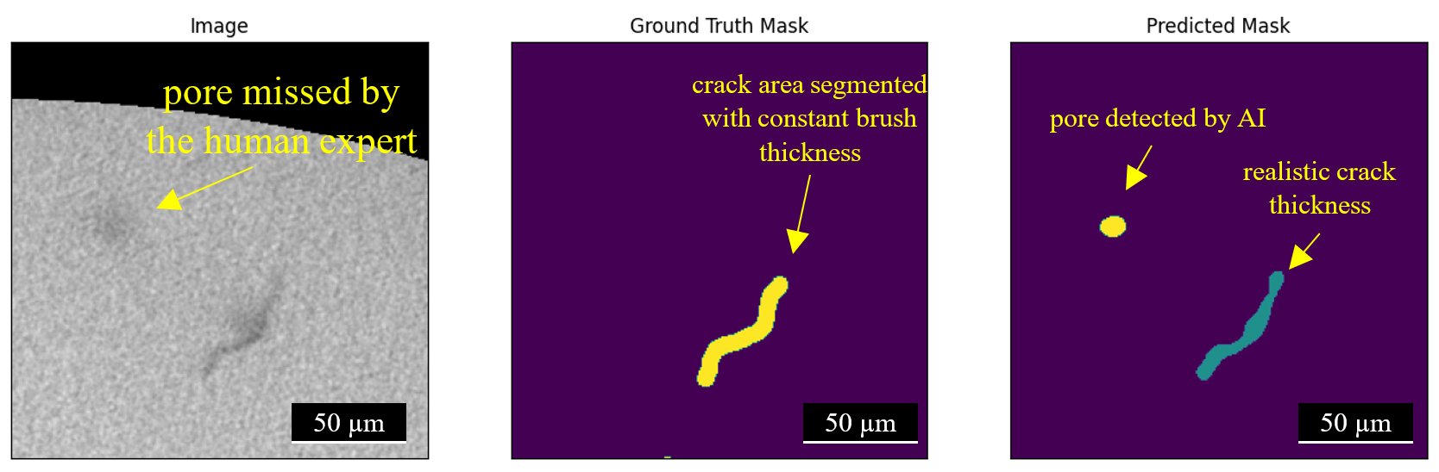

Illustration: AI outperforming a human expert (ground truth mask) during network training.

