A Hybrid Shape Memory Polymer-Filled Metallic Foam Composite with Multiple Functionality
Guoqiang Li & John Konlan, Louisiana State University

Award Title: | Louisiana Materials Alliance (LAMDA)
NSF Award Number: | NSF OIA-1946231
Principal Investigator: | Michael Khonsari
Lead Institution Name: | Louisiana State University
Award Start Date: | 07/01/2020
Award End Date: | 06/30/2025
Highlight Submission Date: | 02/27/2023

What is the outcome or accomplishment? (1-2 short sentences describing it and why it is transformative; 50-word maximum suggested)*
Using advanced mechanical design and manufacturing techniques, LAMDA researchers have developed a lightweight shape memory composite using aluminum metallic open-cell foam as a skeleton that is filled in with a very tough shape memory polymer. The hybrid composite exhibits excellent mechanical properties and possesses the ability to restore its original shape when deformed and strain sensing capability.

What is the impact? (1-2 simple sentences describing the benefits for science, industry, society, the economy, national security, etc.; suggested 50-word maximum)
The hybrid foam enhances sandwich structures due to its super lightweight capability. This type of hybrid composite can be beneficial in many industrial sectors that have a need for a material with a combination of high strength and toughness, low weight, damage sensing, and excellent energy absorption capabilities. This will help NASA and other space exploration agencies to increase the deployment of lightweight smart composite structures to space and provide the Department of Defense with new materials for development of equipment for national security.

What explanation/background does the lay reader need to understand the significance of this outcome? (1-2 paragraphs that might include, for example, more on who, when, where; NSF's role; support from multiple directorates/offices; what makes this accomplishment unique; additional intellectual merits; or broader impacts such as education, outreach, or infrastructure improvement that are integral to this outcome; suggested 150-word maximum)
Lightweight composite structures are widely used in aviation, automobiles, ships, medical equipment, construction, etc. When used in transportation, a huge gain in energy efficiency is realized due to their lightweight architecture. Of the majority of research currently conducted in lightweight structures, very few focus on improving the reusability of these hybrid composites. The disadvantage is that metal foams possess very weak compressive strength and tend to fail under compressive loads. Guoqiang Li’s research group supported by LAMDA has improved the design and manufacturing procedure for making the hybrid composite structure that can resist compression loading. The very tough matrix system improves the compressive property of the hybrid composite and also enables the foam to recover the deformed shape when damaged due to the shape memory effect of the tough polymeric matrix system. This breakthrough will enable other researchers to improve upon their choice of material selection in fabricating lightweight open cell foams and sandwich composite structures.

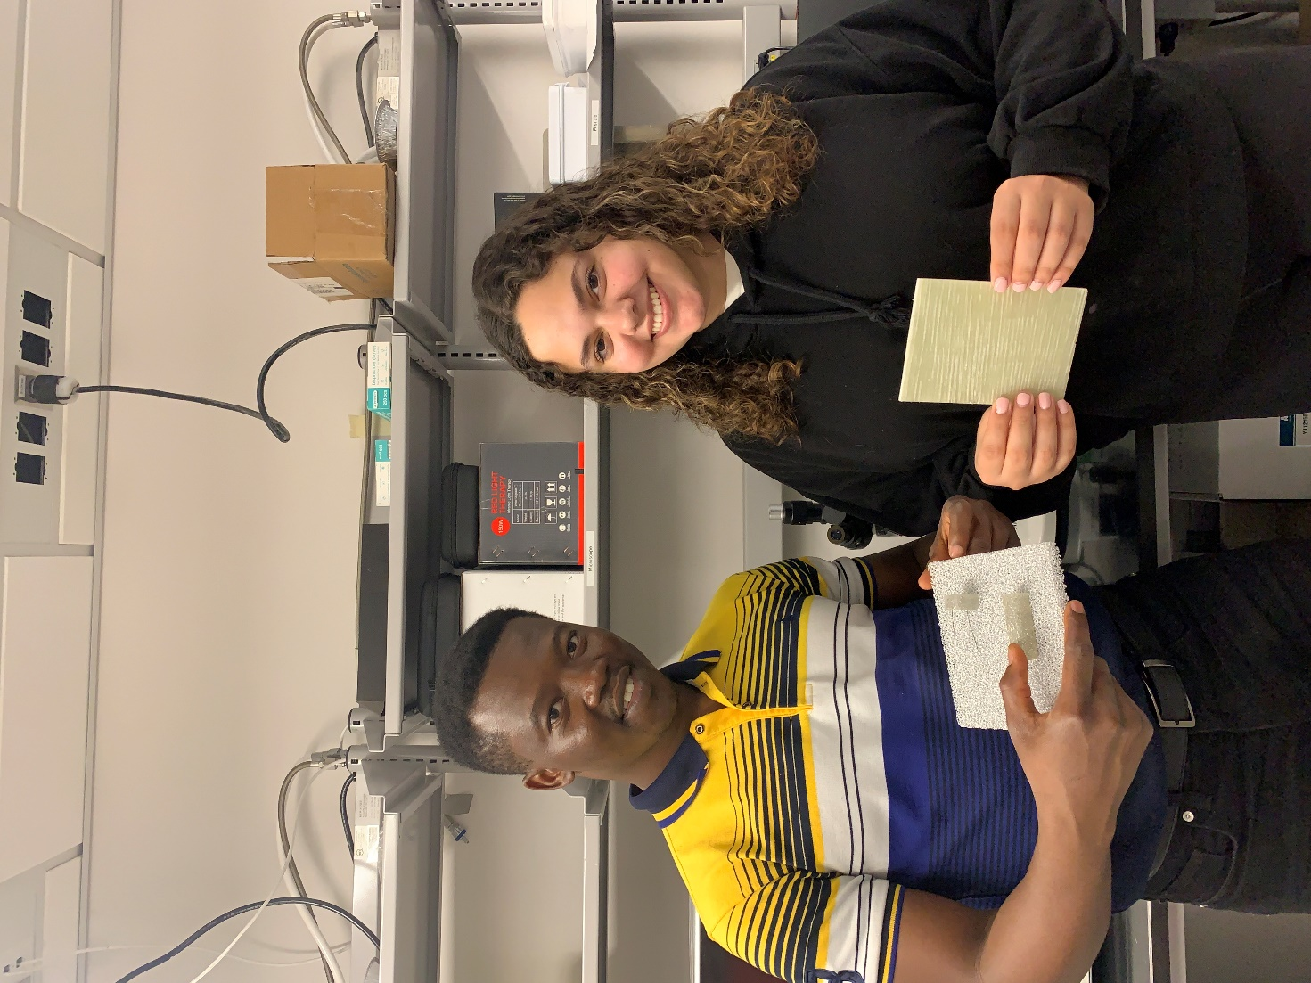
John Konlan, LSU Mechanical Engineering Ph.D. student and LAMDA researcher (left), holds a hybrid-aluminum metal foam shape memory polymer composite, and LSU Mechanical Engineering undergraduate student Jenny Deicaza (right), holds a shape memory polymer composite.

