Embedding Conductors Using MELD Additive Friction Stir Deposition (AFSD) Manufacturing
Dimitris E. Nikitopoulos and Shengmin Guo, Louisiana State University

Award Title: | Louisiana Materials Design Alliance (LAMDA)
NSF Award Number: | NSF OIA-1946231
Principal Investigator: | Michael Khonsari
Lead Institution Name: | Louisiana State University
Award Start Date: | July 1, 2020
Award End Date: | June 30, 2025
Highlight Submission Date: | 02/26/2023

What is the outcome or accomplishment? (1-2 short sentences describing it and why it is transformative; 50-word maximum suggested)*

Conductors have been embedded into a metal part using a solid-state additive friction stir deposition MELD process as a proof of concept. Embedding conductors and sensors into larger-scale metallic hardware during their manufacture is a transformational advance that will make them suitable for integrated, intelligent engineered systems in service.

What is the impact? (1-2 simple sentences describing the benefits for science, industry, society, the economy, national security, etc.; suggested 50-word maximum)

Making metallic hardware with conducting paths and sensors embedded during their manufacture will enable integrated intelligent engineered systems that are more robust, safe, and reliable. They will enable preventive maintenance, rather than reactive maintenance, and the continuous monitoring and control of associated industrial processes.

What explanation/background does the lay reader need to understand the significance of this outcome? (1-2 paragraphs that might include, for example, more on who, when, where; NSF's role; support from multiple directorates/offices; what makes this accomplishment unique; additional intellectual merits; or broader impacts such as education, outreach, or infrastructure improvement that are integral to this outcome; suggested 150-word maximum)

The MELD additive friction stir deposition (AFSD) process is ideal for 3D-printing or repairing larger metal hardware/structures quickly and cost-effectively for aerospace, shipbuilding, automotive, process and energy industry applications. In this solid-state, high-material-deposition-rate process, working temperatures remain below the metal and alloy melting points, producing better material and part property outcomes.

For example, the military is researching AFSD to make armored vehicle hulls, build large parts for ships, and to use for field repairs. The aerospace industry is exploring AFSD to make space-vehicle and aircraft sections. Embedding conductors/sensors in such metal builds would keep critical electrical/electronic paths and components integrated, distributed, and protected within the material of the resulting parts and systems.

Louisiana State University’s Engineering Capstone Design Team 52 is embedding conductors in aluminum builds using MELD AFSD. The team is advised by LAMDA researchers, and funding for the project is provided by the LSU Mechanical and Industrial Engineering Department and the National Center for Advanced Manufacturing. A first proof-of-concept test has been successfully completed.

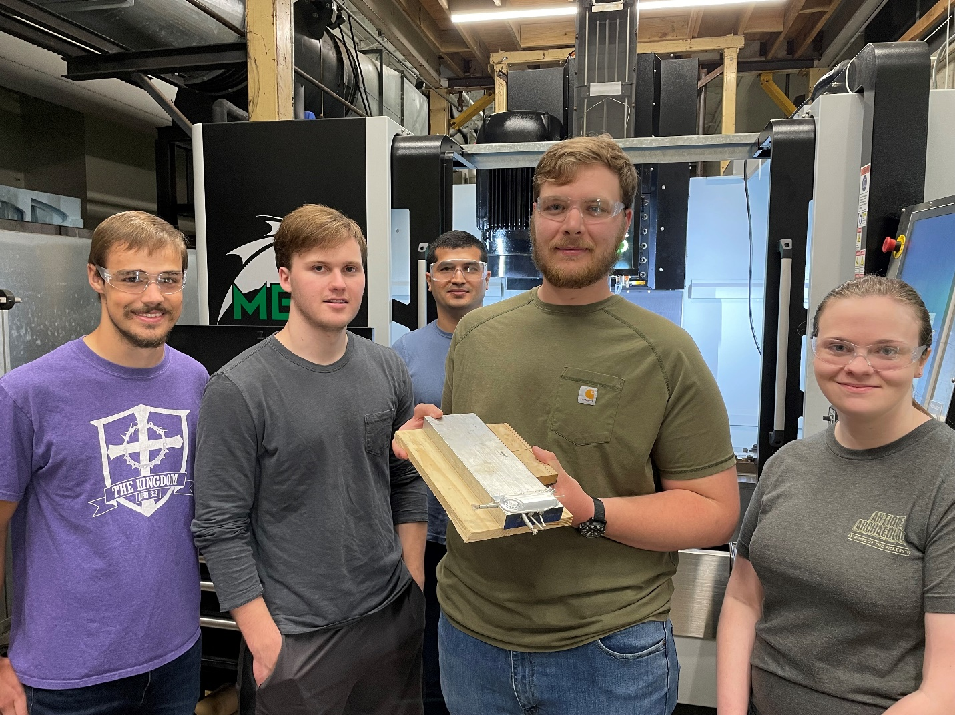
A team of undergraduate students from Louisiana State University has embedded conductors into a metal part using a solid state additive friction stir deposition MELD process. This LSU Capstone Design project was proposed and is directed by Dr. D. E. Nikitopoulos, co-sponsored by the LSU Mechanical & Industrial Engineering Department and through the National Center for Advanced Manufacturing (NCAM), and advised by Dr. S. M. Guo and graduate student Hamed Ghadimi. Pictured, from left to right: Chris Pugh, Mason Pesson, Hamed Ghadimi, Justin Stevens, Karli Beck. Photo by S.M. Guo.

