New and improved materials with shape memory properties
engineered with computational discovery
Collin Wick, Andrew Peters, Anwar Shafe, and Pouria Nourian, Louisiana Tech University
Guoqiang Li, Louisiana State University and Southern University of Baton Rouge

Award Title: | Louisiana Materials Design Alliance (LAMDA)
NSF Award Number: | NSF OIA-1946231
Program Director: | Michael Khonsari
Lead Institution Name: | Louisiana State University
Award Start Date: | August 1, 2020
Award End Date: | July 31, 2025
Highlight Submission Date: | 02/27/2023

What is the outcome or accomplishment? (1-2 short sentences describing it and why it is transformative; 50-word maximum suggested)*
Automated computational methodology was used to identify atomic properties that lead to enhanced shape memory effects (SME). These were then used to engineer epoxies and hardeners with predicted SMEs better than any that have been found, to our knowledge.

What is the impact? (1-2 simple sentences describing the benefits for science, industry, society, the economy, national security, etc.; suggested 50-word maximum)

Shape memory polymers (SMPs) return to their original shape upon stimulus, such as increased temperatures, exerting a force known as the recovery stress. A high recovery stress can be used for many tasks, such as sutures that auto-tighten with body heat, and materials that can self-heal cracks by simply heating it up.
What explanation/background does the lay reader need to understand the significance of this outcome? (1-2 paragraphs that might include, for example, more on who, when, where; NSF's role; support from multiple directorates/offices; what makes this accomplishment unique; additional intellectual merits; or broader impacts such as education, outreach, or infrastructure improvement that are integral to this outcome; suggested 150-word maximum)
SMPs have many applications due to their remarkable ability to change shape in response to external stimuli, such as actuators in smart medical devices that can expand or shrink once the desired location is reached, as self-closing sutures, and in self-healing materials to aid in closing cracks. However, the force exerted during these processes, called recovery stress, is often not strong enough for their widespread use.

Traditionally, to discover and test new SMPs with strong recovery stress could take up to a year, making it a time-consuming and costly process. Fortunately, LAMDA researchers have developed computational methods that can rapidly test SMPs without the need for physical synthesis in the lab, providing results within a week. In addition, the research team has identified atomic fingerprints that can improve the recovery stress of SMPs, further moving beyond the traditional trial-and-error approach to SMP design. This knowledge has enabled the development of a high-throughput screening process that can estimate thousands of possible SMP candidates. Using this approach, we have proposed new SMPs with predicted higher recovery stresses than any previously reported and these advancements in SMP research have the potential to greatly expand their utility and impact on various fields, from biomedical engineering to aerospace.

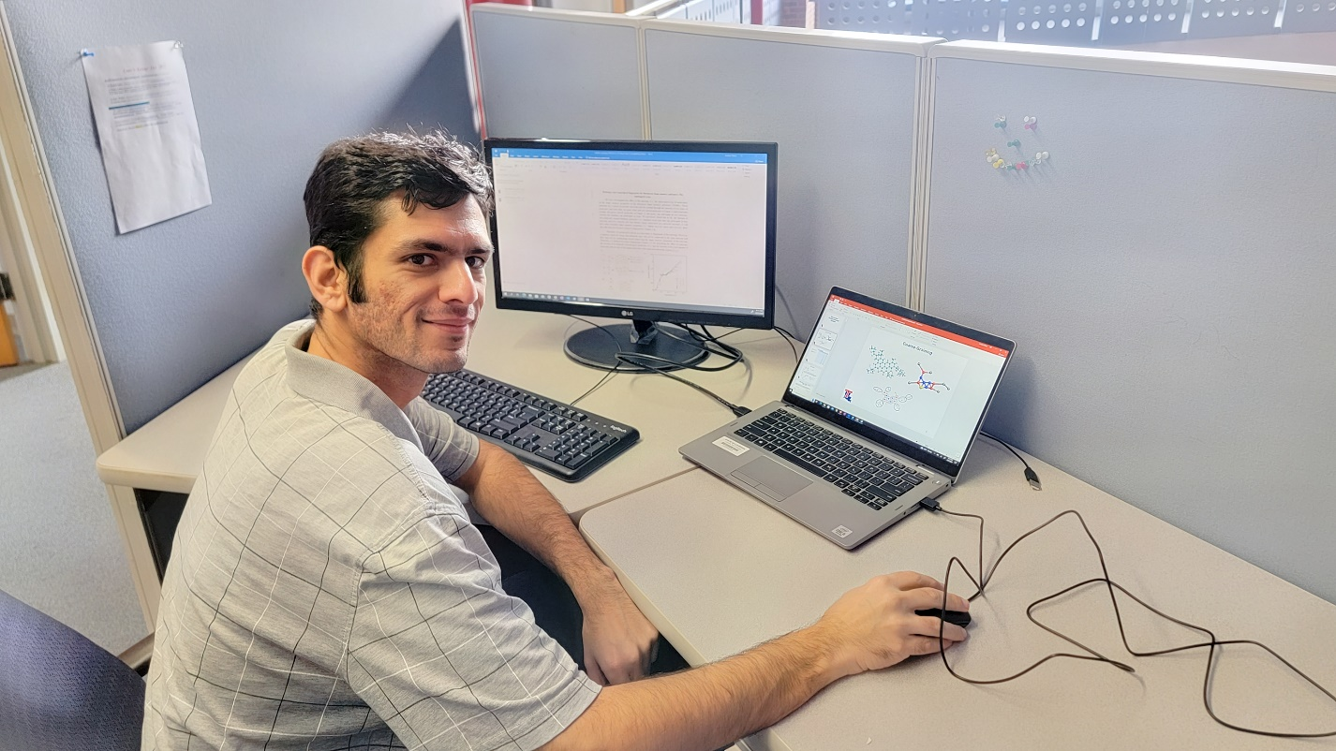
Dr. Pouria Nourian, a postdoc researcher at Louisiana Tech, compiles a report for his work on topological fingerprints for thermoset shape memory polymers.

