LAMDA Seed Awards Facilitate Student Exploration of Novel Manufacturing Technologies and STEM Topics

Award Title: | Louisiana Materials Design Alliance (LAMDA)
NSF Award Number: | NSF OIA-1946231
Principal Investigator: | Michael Khonsari
Lead Institution Name: | Louisiana State University
Award Start Date: | August 2020
Award End Date: | July 2025
Highlight Submission Date: | 03/22/2023

What is the outcome or accomplishment? (1-2 short sentences describing it and why it is transformative; 50-word maximum suggested)*
The Louisiana Materials Design Alliance (LAMDA) developed a STEM Outreach track for the Seed Award program to further K-12 outreach and education in STEM and advanced manufacturing.

What is the impact? (1-2 simple sentences describing the benefits for science, industry, society, the economy, national security, etc.; suggested 50-word maximum)
Six awardees have been selected for funding in the new program so far, and are providing high quality STEM programming and stimulating interest in STEM careers. The awards range from programming aquatic robot eels, multi-disciplinary outreach in the physical sciences to middle school students in rural parishes, additive manufacturing summer camps, and mechanical engineering workshops for high school students.

In one example, LAMDA seed award recipient, Dr. Genevieve Palardy, Assistant Professor of Mechanical Engineering at Louisiana State University, LAMDA researcher, and NSF CAREER award winner, provided a two-part workshop at Denham Springs High School, introducing participants to additive manufacturing techniques, such as digital light processing, and the mechanical engineering design process through using AutoCAD Inventor. The goal of the workshop was to give students access to the knowledge behind 3D printing, and the necessary resources to print their own devices.

Participants not only received class credit and a CAD certification, but they learned each step of 3D printing, from initial conception and design through to actual printing. 3D printers were left with the schools so participants can hone their skills, teach others about additive manufacturing, and increase interest and competency of other high school students. Dr. Palardy plans to extend this program to additional schools in the future.

What explanation/background does the lay reader need to understand the significance of this outcome? (1-2 paragraphs that might include, for example, more on who, when, where; NSF's role; support from multiple directorates/offices; what makes this accomplishment unique; additional intellectual merits; or broader impacts such as education, outreach, or infrastructure improvement that are integral to this outcome; suggested 150-word maximum)

Building a skilled workforce in Louisiana directly related to additive manufacturing starts with the students getting ready to head to college or industry to begin their careers. Developing a relationship with the educators and researchers gives the students exposure to STEM topics and a better understanding of STEM careers and applications. Many students expressed interest in pursuing these topics in their future careers or college programs. With the explosion of interest in 3D printing, this outreach also provided the necessary background to teachers on how best to introduce additive manufacturing to future students.
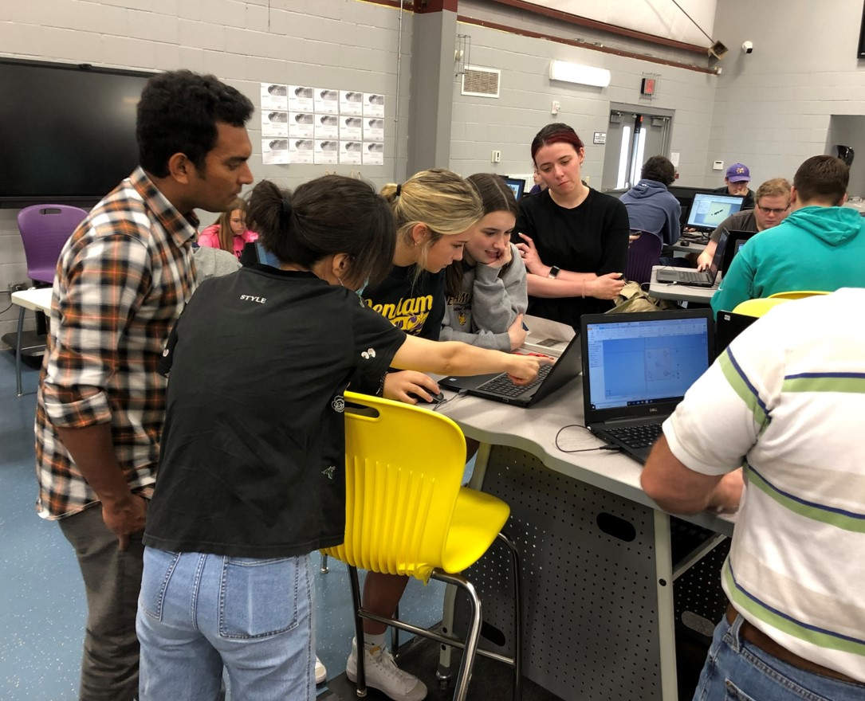
Mechanical Engineering students from Dr. Genevieve Palardy’s group work with Denham Springs High School STEM and Robotics Center students on their 3D printing model.

